**Dharmsinh Desai University, Nadiad**

**Department of Information Technology**

**Advanced Java Technology, IT619**

**B.Tech. IT, Sem: VI**

**Experiment – 04**

**Submitted By**

**Roll No.:IT076**

**Name: DISHANT MODH**

**Aim:**  Create login and view result functionality with the session management. The login

servlet logons the user with the exam-result section and allows access of viewing his/her

exam-result

**Code:**

**🡪xml File: -**

<?xml version="1.0" encoding="UTF-8"?>

<web-app version="3.1" xmlns="http://xmlns.jcp.org/xml/ns/javaee" xmlns:xsi="http://www.w3.org/2001/XMLSchema-instance" xsi:schemaLocation="http://xmlns.jcp.org/xml/ns/javaee http://xmlns.jcp.org/xml/ns/javaee/web-app_3_1.xsd">

<servlet>

<servlet-name>Login</servlet-name>

<servlet-class>Login</servlet-class>

</servlet>

<servlet>

<servlet-name>result</servlet-name>

<servlet-class>result</servlet-class>

</servlet>

<servlet-mapping>

<servlet-name>Login</servlet-name>

<url-pattern>/Login</url-pattern>

</servlet-mapping>

<servlet-mapping>

<servlet-name>result</servlet-name>

<url-pattern>/result</url-pattern>

</servlet-mapping>

<session-config>

<session-timeout>

30

</session-timeout>

</session-config>

</web-app>

**🡪JSP File: -**

<!DOCTYPE html>

<!--

To change this license header, choose License Headers in Project Properties.

To change this template file, choose Tools | Templates

and open the template in the editor.

-->

<html>

<head>

<title>Student Login</title>

<meta http-equiv="Content-type" content="text/html; charset=UTF-8">

</head>

<body>

<h1>Login Form</h1>

<form action="Login">

<table>

<tr>

<td>username</td>

<td><input type="text" name="uname"></td>

</tr>

<tr>

<td>password</td>

<td><input type="password" name="pass"></td>

</tr>

<tr>

<td><input type="submit" value = "login"></td>

</tr>

</table>

</form>

</body>

</html>

**🡪Login Servlet**

/*

* To change this license header, choose License Headers in Project Properties.

* To change this template file, choose Tools | Templates

* and open the template in the editor.

*/

/**

*

* @author DMX

*/

import java.io.IOException;

import java.io.PrintWriter;

import java.sql.*;

import javax.servlet.ServletException;

import javax.servlet.http.HttpServlet;

import javax.servlet.http.HttpServletRequest;

import javax.servlet.http.HttpServletResponse;

import javax.servlet.http.HttpSession;

public class Login extends HttpServlet {

Connection cn = null;

ResultSet rs = null;

PreparedStatement ps = null;

String driver = "org.apache.derby.jdbc.ClientDriver";

String url = "jdbc:derby://localhost:1527/Login";

String query = "select * from login";

HttpSession hs = null;

int flag = 0;

protected void processRequest(HttpServletRequest request, HttpServletResponse response)

throws ServletException, IOException {

response.setContentType("text/html;charset=UTF-8");

PrintWriter out = response.getWriter();

try {

out.println("<html>");

out.println("<head>");

out.println("<title>Welcome TO DC world</title>");

out.println("</head>");

out.println("<body>");

out.println("<center><h1> Welcome "+ request.getParameter("uname") +"</h1></center>");

try{

Class.forName(driver);

cn = DriverManager.getConnection(url,"dmx","dmx");

}

catch(Exception e)

{

out.println("Exception Occured:");

}

String dbusername = null;

String dbpassword = null;

String username = null;

String password = null;

try{

username = request.getParameter("uname");

password = request.getParameter("pass");

ps = cn.prepareStatement(query);

rs = ps.executeQuery();

while(rs.next())

{

dbusername = rs.getString(1);

dbpassword = rs.getString(2);

if(dbusername.equals(username) && dbpassword.equals(password))

{

flag = 1;

hs = request.getSession();

hs.setAttribute("uname",dbusername);

break;

}

}

if(flag == 1)

{

out.println("Logged In");

out.println("<a href = result>View Result</a>");

}

else

out.println("<h2>Something is worng:<h2>");

}

catch(Exception xe)

{ }

}

catch(Exception te)

{

System.out.println("Exception Occured:");

}

finally{

out.println("</body>");

out.println("</html>");

}

}

@Override

protected void doGet(HttpServletRequest request, HttpServletResponse response)

throws ServletException, IOException {

processRequest(request, response);

}

@Override

protected void doPost(HttpServletRequest request, HttpServletResponse response)

throws ServletException, IOException {

processRequest(request, response);

}

@Override

public String getServletInfo() {

return "Short description";

}// </editor-fold>

}

**🡪Result Servlet: -**

/*

* To change this license header, choose License Headers in Project Properties.

* To change this template file, choose Tools | Templates

* and open the template in the editor.

*/

/**

*

* @author DMX

*/

import java.io.IOException;

import java.io.PrintWriter;

import java.sql.*;

import javax.servlet.ServletException;

import javax.servlet.http.HttpServlet;

import javax.servlet.http.HttpServletRequest;

import javax.servlet.http.HttpServletResponse;

import javax.servlet.http.HttpSession;

public class result extends HttpServlet {

Connection cn = null;

ResultSet rs = null;

PreparedStatement ps = null;

String driver = "org.apache.derby.jdbc.ClientDriver";

String url = "jdbc:derby://localhost:1527/Login";

String query = "select * from result";

HttpSession hs = null;

protected void processRequest(HttpServletRequest request, HttpServletResponse response)

throws ServletException, IOException {

response.setContentType("text/html;charset=UTF-8");

try (PrintWriter out = response.getWriter()) {

/* TODO output your page here. You may use following sample code. */

out.println("<!DOCTYPE html>");

out.println("<html>");

out.println("<head>");

out.println("<title>Servlet result</title>");

out.println("</head>");

out.println("<body>");

out.println("<center><h1>Exam Result Section</h1></center>");

try{

Class.forName(driver);

cn = DriverManager.getConnection(url,"dmx","dmx");

}

catch(Exception e){ }

String dbusername = null;

String username = null;

try{

hs= request.getSession(false);

username = (String)hs.getAttribute("uname");

ps = cn.prepareStatement(query);

rs = ps.executeQuery();

int flag = 0;

while(rs.next())

{

dbusername = rs.getString(1);

if(dbusername.equals(username))

{

flag = 1;

out.println("<h1><center>Welcome, "+username+"</center></h1><hr>");

out.println("<p>Your Result is:</p><hr>");

ResultSetMetaData rs1 = rs.getMetaData();

int total=0;

out.println("<table><tr><th>Subject Name</th><th>Marks</th></tr>");

for(int i=2; i<=rs1.getColumnCount(); i++){

total += rs.getInt(i);

out.println("<tr><td>"+rs1.getColumnName(i)+"</td>"+"<td>"+rs.getInt(i)+"</td></tr>");

}

out.println("</table border=\"1\"><hr>");

out.println("<p>Total Marks : "+total+"</p>");

out.println("<p>Average Marks : "+(total/(rs1.getColumnCount()-1))+"</p><hr>");

out.println("<p>Back to the Login: <a href=\"index.jsp\">click here</a></p>");

}

}

if(flag == 0)

out.println("<h3>Sorry your result is under progress:</h3>");

}

catch(Exception e) { }

out.println("</body>");

out.println("</html>");

}

}

@Override

protected void doGet(HttpServletRequest request, HttpServletResponse response)

throws ServletException, IOException {

processRequest(request, response);

}

@Override

protected void doPost(HttpServletRequest request, HttpServletResponse response)

throws ServletException, IOException {

processRequest(request, response);

}

@Override

public String getServletInfo() {

return "Short description";

}// </editor-fold>

}

**Input/Output:**

1. **Login Page:**

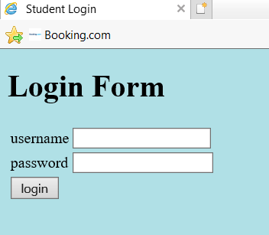

1. **When we only enter the username and password box is empty them:**

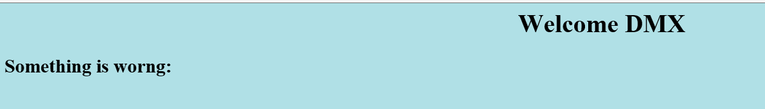

1. **When entering the Username and the password.**

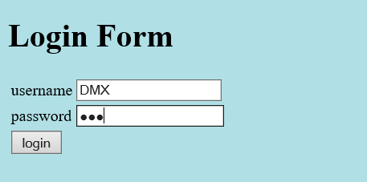

1. **After entering the username and password the login servlet will call page**



1. **After clicking the “View Result” it will call the Result Servlet.**

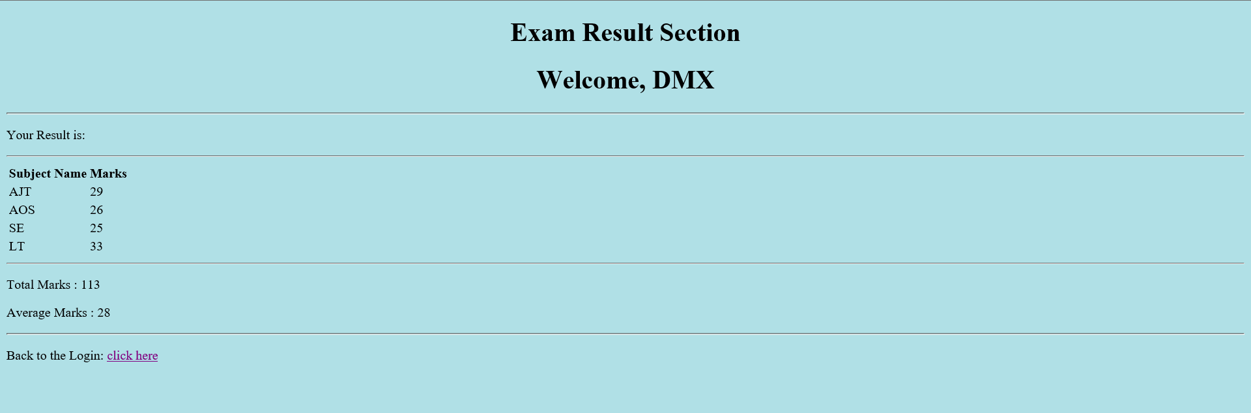

1. **Login Database**

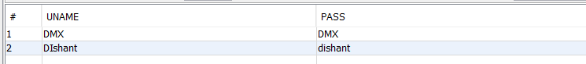

1. **Result Database**

